Problem 1 – Exact Probabilities
To calculate the probability of exactly r successes in n Bernoulli trials is .
This formula only works in trials where there is a binomial distribution and the events are independent of each other.

On the calculator, use the Bernoulli formula to determine the probability that a packet of ten memory chips with an average of 2% defective chips has no defects.  In this case, n = 10, r = 0, p = 0.02, q = 0.98  - P(0) =  Now, verify your calculations using the Binomial Pdf command. To access the command, press  . |  | 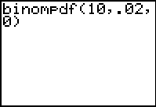
To calculate the probabilities of 1, 2, 3, 4, and 5 defective memory chips, enter 0 through 5 in list L1. Then highlight L2 and enter the formula binompdf(10, 0.02, L1). Press . The probabilities for the respective number of defective chips are displayed. |  | 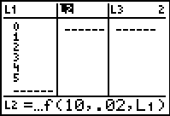
Use the L3 and L4 to find the probabilities of defective chips in a packet of 25 chips with an average of 2% defective and a packet of 10 chips with an average of 30% defective.  Enter the probabilities in the table at the right.
  r | n = 10  p = 0.02 | n = 25  p = 0.02 | n = 10  p = 0.3
  0 | .
  1
  2
  3
  4
  5
- How does the distribution of probabilities for 30% defective compare to the distribution of 2% defective?

Problem 2 – Cumulative Probabilities
Let’s explore the first example where memory chips were bought in packets of ten where 2% of the memory chips are defective on average. On home screen, calculate the probability that there are less than three defective memory chips.
Add together the probabilities of 0, 1, and 2 that were calculated in Problem 1.
- P(less than 3 defects) =

To verify your answer, use the Binomial Cdf command. To access this command, press  . |  | 