Part 1 – Creating the Original Image
In this activity, you are going to graph an image and then explore the impact of changing all the x-values by a certain amount or changing the y-values by a certain amount. Lists will be used to draw an image on the calculator screen.
1. Write the coordinates all of points on the original tree.
A | ( , ) | H | ( , ) | O | ( , )
B | ( , ) | I | ( , ) | P | ( , )
C | ( , ) | J | ( , ) | Q | ( , )
D | ( , ) | K | ( , ) | R | ( , )
E | ( , ) | L | ( , ) | S | ( , )
F | ( , ) | M | ( , ) | A | ( , )
G | ( , ) | N | ( , )

2. How do you think we can make the tree taller?

3. How do you think we can make the tree shorter?

4. What do you think would happen if we doubled all the x-coordinates?

5. Now enter the coordinates above as L1 and L2. All x-values are entered (in order) in L1. The y-values are entered (in order) in L2. Press S and select 1:Edit… to open L1 and L2.
To setup the STAT PLOT press ` å and configure as shown. | 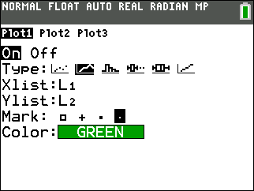
Work with your teacher to select an appropriate Window. Press @ to change the values.  Press % to view the tree.  Draw the tree as best you can at the right. | 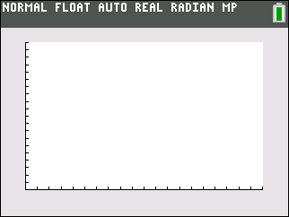

Part 2 – Changing x-values
6. First, let’s change the x-values by doubling all the numbers. To do this, press S and select 1:Edit…, and then move to the top of L1. Then, press ` ò 1 to select L1, * 2 to multiply by 2, and e to execute the command. How did all the values in the list change?  7. Predict how the graph of the tree will change.  8. Press % to see the new tree. Draw it at the right.  9. If your prediction in Question 7 was not correct, how did the graph change? | 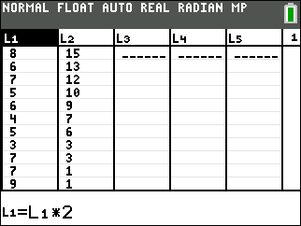
Part 3 – Changing y-values
Before changing the y-values of the original tree, you must change the x-values back to original values. You will need to divide the list by 2. Follow the same procedure in Question 6 except divide by 2. Then, multiply the y-values by 2. Again, use the same procedure as in Question 6.

10. Predict how the graph of the tree will change.

11. Press % to see the new tree. Draw it at the right.
12. If your prediction in Question 10 was not correct, how did the graph change?

13. If you divide the original lists by 2, what do you predict will happen?

14. How would you make the tree both taller and wider?

