Going Back To Your Roots  ID: 11758 | Time Required  40 minutes

Activity Overview
In this activity, students apply the Fundamental Theorem of Algebra in determining the complex roots of polynomial functions. The theorem is applied both algebraically and graphically.

Topic: Polynomial Functions
- Fundamental Theorem of Algebra
- Complex roots
- Multiplicity

Teacher Preparation and Notes
- Problems 1 through 3 are to be done in class. The extension can be used for further exploration of the topic. Additional practice is provided on the associated worksheet for guided practice or homework.
- To download the student worksheet, go to education.ti.com/exchange and enter “11758” in the quick search box.

Associated Materials
- PrecalcWeek16_BackToRoots_worksheet_TI84.doc

Suggested Related Activity
To download any activity listed, go to education.ti.com/exchange and enter the number in the quick search box.
- Discriminating Against the Zero (TI-84 Plus family) — 11520

Before beginning the activity, it is important that students understand how to determine the degree of a polynomial and the definition of a complex number.

Problem 1 – The Fundamental Theorem of Algebra
In this activity, students are introduced to the Fundamental Theorem of Algebra and apply it in obtaining all complex roots of polynomial functions. After introduction of the theorem, explain to students that all real numbers can be written as complex numbers. For example, the number 3 can be written as 3 + 0i. Therefore, every real zero is also a complex zero.
Students will consider the polynomial f(x) = x³ + x². To factor this polynomial, they will need to first factor out the greatest common factor of x³and x², which is x². Further simplification to linear factors yields f(x) = x²(x + 1) = x·x·(x + 1).
Then students are to graph the functions and use the zero command from the CALCULATE menu to determine the roots. At this time, the multiplicity of each root is introduced. Make sure that students understand that multiplicity is the number of times a factor shows up in a polynomial.  Students should notice that the multiplicities of all roots or zeros add up to the degree of the polynomial. The degree is the highest power on the variable in the expanded form of the polynomial. | 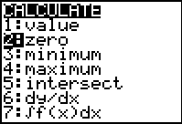  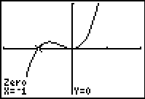
Problem 2 – Beyond Real
In this section, students explore the graph of a polynomial with no real roots. They are to graph the function f(x) = x² + 9 and then use the graph to determine how many complex roots and what type of roots it has. They should see that since the graph does not cross the x-axis it has two imaginary roots.  You may need to explain the difference between a complex number and an imaginary number. An imaginary number is a complex number, a + bi, where a = 0, b ≠ 0, and i = .  Students are to use the quadratic formula on the Home screen to identify all complex roots for the polynomial. | 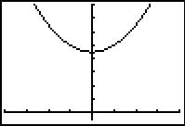  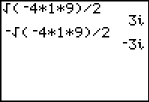

Problem 3 – The Mixed Case
Students are provided with a polynomial that has both real and imaginary roots. The graph illustrates the real root and other methods must be employed to find the remaining roots.  Students are to determine the roots applying a combination of such methods as synthetic division, polynomial long division, completing the square, and the quadratic formula.  Confirm with students that the sum of the multiplicities of the roots equals the degree of the polynomial. | 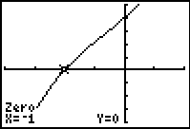  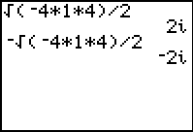
Extension – Even and Odd Multiplicity
In this problem, students explore the effect of even and odd multiplicities of roots by first looking at two specific graphs already in factored form. They need to compare the graph at the x-value of the root and the multiplicity of the root.  Students should begin to see that for roots with even multiplicities, the graph touches but does not cross the x-axis at that x-value. For roots with odd multiplicities, the graph does cross the x-axis at that x-value. | 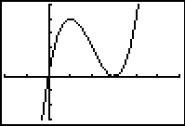
Students then use the transformational graphing application to explore how the multiplicity value affects the graph of the polynomial. They should understand that the root of f(x) = xª is x = 0.  As part of further exploration, students can change the function to have other roots, such as  f(x) = (x – 2)ª. | 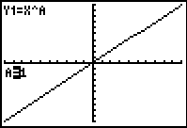
Application & Practice Answers
Polynomial | Factor(s) | Roots | Multiplicities
f(x) = x⁴ – 9x³ + 27x² – 31x + 12 | x – 4  x – 3  x – 1 | 4  3  1 | 1  1  2
f(x) = x³ – 7x² + 11x – 5 | x – 5  x – 1 | 5  1 | 1  2
f(x) = x⁵ + 9x⁴ + 31x³ + 63x² + 108x + 108 | x – 2i  x + 2i  x + 3 | 2i  –2i  –3 | 1  1  3

