Average Roller Coaster  ID: 12216 | Time Required  15 minutes

Activity Overview
In this activity, students will graphically discover how to find the average value of a function. This exploration uses animation and graphical observations to develop understanding. Additionally, students will review concepts like average rate of change and using the Trapezoid Rule to find the definite integral when given only data.

Topic: Average Value of a Function
- Average value of a velocity function
- Average rate of change versus average value of a function

Teacher Preparation and Notes
- This activity can serve as an exploration and discovery of the average value of a function in the context of the speed of a roller coaster.
- Students should clear functions before beginning this activity by pressing  in the Y= screen, and selecting 8:Clear Functions.
- Students will need to download the following files before beginning the activity: animate.89p, avecoast.89p, and grimages.tig. The first two are programs used to generate the graphs for Questions 4 and 5 of Part 1 on the student worksheet. The third, grimages.tig, contains the images needed for the programs and Question 7 of Part 1 on the worksheet and should be downloaded as a group file.
- To download the calculator programs, graph files, and student worksheet, go to education.ti.com/exchange and enter “12216” in the quick search box.

Associated Materials
- CalcWeek22_AvgValueOfFun_Worksheet_TI89.doc
- animate.89p
- avecoast.89p
- grimages.tig

Suggested Related Activities
To download any activity listed, go to education.ti.com/exchange and enter the number in the quick search box.
- Average Value (TI-89 Titanium) — 3275
- Xtreme Calculus: Part 2 (TI-89 Titanium) — 11487

Part 1 – Discover/Explore Average Value of a Function
This activity begins with trying to help students make connections with what they already know about finding the average and how this needs to be improved to correctly find the average value of a function. A graph of the definite integral of a function is compared with the area that has the average value as its height and the difference of b and a as the base. | 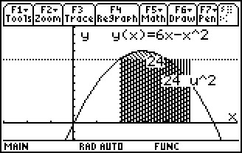
For further discussion, or to help the students make additional observations to answer Question 6 on the student handout, ask the students to calculate y(2) and y(5). What is the average of those values? How does this compare with the actual average value of the function?
The section concludes with graphical observations of the velocity-time graph. To view the graph coast, students should first turn off the axes on the graph screen. Then, on the HOME screen, students should enter the command RclPic coast. The horizontal line is graph a and the parabola is graph b.
Student Solutions
1. Add up the values and divide by the number of values to find the average of discrete values.
2. No, 7 would be too small if the object traveled 15 m/s for four-fifths of the time.  3. Sketch should be similar to the graph on the right It starts out slow and speeds up then slows back down again.  4. The integral is 24. | 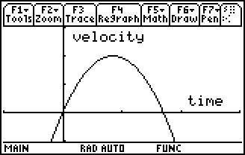
5.
6. The area of the rectangle with a height equal to the average velocity is equal to the integral on that same interval. The average velocity is not equal to the average of the initial and final velocity.
7. The graph labeled b represents the roller coaster. The graph labeled a would be a very boring roller coaster idea.

Part 2 – Extension/Homework
This section begins with three “non-calculator questions” that involve students finding the average value, mean value and average rate of change of different functions.
The other four problems in this section are “calculator permitted” questions. The final question has students find the average value using the Trapezoid Rule.
Student Solutions
1. . So
2.
3.
4.
5. . So b = 3 or –4. Students should use the Solve feature to solve for b.
This can be solved without the use of technology if students recall how to factor b³ – 1.
6. Students can use the Trapezoid Rule formula =
Answer: 4.63 mi/min

