Introduction
Suppose a volunteer from the class becomes the most popular person in the school—everyone wants to be close to this person. How can you arrange yourselves to all be equally close to the person?
Two volunteers are now equally popular but very jealous—everyone wants to be close to them, but never closer to one than the other. How could the friends of these two people arrange themselves?
Consider one very popular person standing alone, and the most popular group, lined along the wall at the school dance, hand in hand. How will others arrange themselves so as to be equally close to both the individual and any single person from the group?

Problem 1 – Perpendicular Bisector
Take a sheet of paper and place a point in the center.  Choose at least ten points along one of the long sides of the paper and mark each point on the long side.  Fold the paper so that one mark on the long side touches P. Do this for each mark.  - Trace along the folds. What does this locus resemble?  - What does the crease represent? |  | •  P  P  P  P  •
Problem 2 – Shape of the Curve
Graph the parabola.  The focus is (2, 2) and the x-axis is the line which we call the directrix.  Complete the following table. | 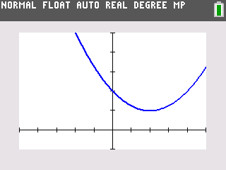
  Point | Distance from (2, 2) | Distance from x-axis
  (2,1)
  (1,1.25)
  (5, 3.25)
  (0, 2)
Graph the parabola y = (x – 3)² + 0.25.  The focus is (3, 0.5) and x-axis is the directrix.  Complete the following table. | 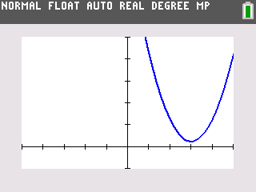
  Point | Distance from (3, 0.5) | Distance from x-axis
  (3, 0.25)
  (0, 9.25)
  (2, 1.25)
  (5, 4.25)
Graph the parabola .  The focus is (1, –1) and the x-axis is the directrix.  Complete the following table. | 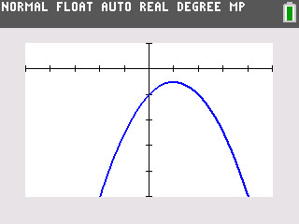
  Point | Distance from (1, –1) | Distance from x-axis
  (1, –0.5)
  (0, –1)
  (–1, –2.5)
  (4, –5)
- What do you notice about the two distances in the tables? Why does this happen?

- What effect does the coefficient of the squared term have on the shape of the parabola?

- What effect does the distance between the focus and the directrix have on the shape of the parabola?

- What do you notice about the distance between the focus and the vertex in regard to the coefficient of the square term?

Problem 3 – Fitting a Parabola
The general equation for a parabola that opens up or down is 4p(y – k) = (x – h)², where (h, k) is the vertex and p is the directed distance from the vertex to the focus F. When p > 0 the parabola opens up; and when p < 0, the parabola opens down.
Suppose we have a parabola with focus (0, 4) and a directrix of the x-axis. We want to find the equation of the parabola. Use the following questions to help determine the equation.
What is the vertex?
What is distance from the vertex to the focus?
What is the coefficient to the square term?
What is the equation?
1. What is the equation of the parabola with focus at (0, 4) and directrix on the x-axis?

2. What is the equation of the parabola with the focus at (2, 3) and directrix y = 0?

3. What is the focus for the parabola with equation y = 0.125(x – 3)² + 2?

4. What is the significance of the coefficient of x in each of these equations?

5. What is the general form for the equation of a parabola with its focus located at (a, b) and directrix on the x-axis?

