Open the TI-Nspire document What’s_in_a_Line.tns.  In this activity, you will explore linear and non-linear functions by examining many graphs, tables, and equations. By the end of your explorations, you should be able to look at a given equation and decide, just from the equation, if it is a linear function or not. But first, let's look at graphs, tables AND equations and see what patterns and relationships we notice. | 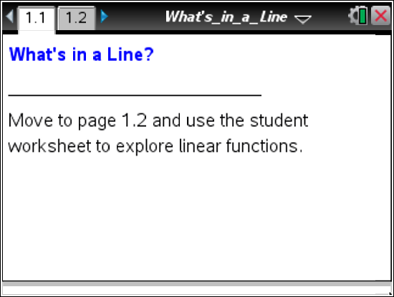

Move to page 1.2.

1. Examine the features you see on Page 1.2 with your partner. Describe what you notice on the page itself as well as what actions you can perform. In this activity, you’ll use these features to explore what makes a linear function.
2. Plot the four points listed in the initial table by grabbing and dragging one point at a time to its appropriate coordinates.
a. Do the points appear to lie on a line (a linear function)? Test this idea by plotting three more points that you believe would be on the same line.

b. Use the slider to check whether the points lie on a linear function. What did you find?

3. After you check to see whether your points are part of a linear function, an equation that represents the function will appear with the graph. Write the x- and y-coordinates, including your three from the first example, in the table below organizing the x-values in increasing order (and then matching the y-value). Write the equation that appeared next to the line:
y =
x | y

a. If you were only given the equation, how could you determine the (x, y) coordinates for points that lie on the linear function?

b. In your own words, describe the relationship between the x- and y-coordinates.

c. Examine the ordered values in the table, but instead of looking for patterns between the x- and
y-values, look for patterns as the x- and y- values increase. What do you notice?

4. Use the “New” button on the top left of the page to provide a new table of values. Before you plot the points, examine the pairs of coordinates, and look for a pattern within the table.
a. Do you believe these points will lie on a line (a linear function)? Explain your thinking with others in your group. Provide support for your thinking by describing any pattern you notice in the table of points.

b. Use this pattern to help you describe an equation, or rule, to find even more points. Share your thinking with others and write your “test” rule below:
y =
c. Now plot the points to test your conjecture (another word for “guess”). Do the points appear to lie on a line? Plot more points to test your thinking.

d. What was the final equation for the second example?
y =

How does this compare with your conjecture above? Does this equation describe a linear function? Explain your reasoning with others in your group.

5. In your group, examine the next three examples to determine whether they represent linear functions or not.
a. BEFORE you plot the points for any example, examine the table of (x, y) values, and make a prediction about whether the points will lie on a line or not. If they will lie on a line, provide support for your response by referring to a “linear” pattern you notice in the table of (x, y) pairs and the points on the graph.
b. After your group agrees on whether the points will lie on a line, plot the points to test your conjecture. After plotting the original four points, continue to plot more points, and finally use the slider to test your plotted points.
In each example, develop a rule or equation that would describe how to find any possible
(x, y) pair. Write your equations below prior to testing them out.
Test equation for example 3: y =

Test equation for example 4: y =
Test equation for example 5: y =

- For each example, write the final equation you found below.
Final equation for example 3: y =
Final equation for example 4: y =
Final equation for example 5: y =

6. Write all five equations you have worked with so far in the spaces below:
(1) y = (2) y = (3) y = (4) y = (5) y =

a. Which of these equations represent linear equations?

b. What common features are there among the linear equations that can help you describe any equation of a linear function? What might a general form for a linear equation look like?

7. What were the patterns you noticed in the tables that suggested the plotted points would be on lines?

8. In your group, look at the next four examples (6 through 9), and decide whether they represent linear functions or not. Use a similar process as before:
1) look for and describe patterns in the table of (x, y) pairs that have previously indicated a linear function;
2) plot the four points from the table to see if they visually appear to lie on a line;
3) try to develop a rule or equation that will help you find three more points to plot; and finally
4) check to determine the final equation for the example and to compare with your conjecture.
Describe your findings below.
Example 6:

Example 7:

Example 8:

Example 9:

9. a. Describe all equations that would represent linear functions.

b. Give an example of an equation that would not represent a linear function.

