Open the TI-Nspire™ document Multiplication_and_Division_of_ Rational_Numbers.tns.  In this activity, you will represent multiplication and division of positive decimals and mixed numbers using an interactive area model. | 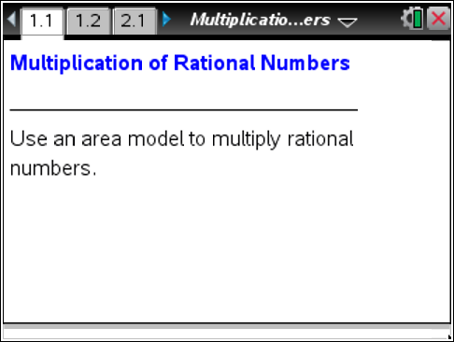

Move to page 1.2.

For each multiplication problem, the factors represent the height and the width of the rectangle.
1. What is the geometric meaning of the product of two factors?

Grab and drag the white points to adjust the height and the width of the rectangle in order to model the multiplication problem. After you find the area, double-click the solution box on Page 1.2, and enter your answer. If your answer is correct, a check mark will appear. Note: Do not delete the decimal point in the box.
2. Find the value of using the area model on Page 1.2. Show all the steps you used to calculate your answer and explain your reasoning.

3. Click the right arrow in the top right corner of Page 1.2 to generate several new multiplication problems. For each problem:
a. Record the problem in the chart provided at the end of this worksheet.
b. Model the problem using the interactive area model on Page 1.2.
c. Find the product, and show all the steps of your calculations in the chart.
d. Check your calculations by entering your answer into the solution box on Page 1.2. Correct your work as needed.
e. Place a check mark in the “✓” box when your answer is correct.

4. Click the up arrow on the right side of Page 1.2 to change the problem to multiplication of mixed numbers. Find the value of using the area model. Show all the steps you used to calculate your answer and explain your reasoning.

5. Click the right arrow in the top right corner of Page 1.2 to generate several new multiplication problems. For each problem:
a. Record the problem in the chart provided at the end of this worksheet.
b. Model the problem using the interactive area model on Page 1.2.
c. Find the product, and show all the steps of your calculations in the chart.
d. Check your calculations by entering your answer into the solution box on Page 1.2. Correct your work as needed.
e. Place a check mark in the “✓” box when your answer is correct.

Move to page 2.1 and then to page 2.2.

For each division problem, the dividend represents the area of the rectangle and the divisor represents the height of the rectangle.
6. What is the geometric meaning of the quotient?

Grab and drag the white points to adjust the height and the width of the rectangle in order to model the division problem. Move the white point on the left side of the model to represent the divisor; move the white point on the bottom of the model until the rectangular area represented by the model equals the dividend. After you find the quotient, double-click the solution box on Page 1.2, and enter your answer. If your answer is correct, a check mark will appear. Note: Do not delete the decimal point in the box.
7. Find the value of using the area model on Page 2.2. Show all steps used to calculate your answer and explain your reasoning.

8. Click the right arrow in the top right corner of Page 2.2 to generate several new division problems. For each problem:
a. Record the problem in the chart provided at the end of this worksheet.
b. Model the problem using the interactive area model on Page 2.2.
c. Find the quotient, and show all the steps of your calculations in the chart.
d. Check your calculations by entering your answer into the solution box on Page 2.2. Correct your work as needed.
e. Place a check mark in the “✓” box when your answer is correct.

9. Click the up arrow on the right side of Page 2.2 to change the problem to division of mixed numbers. Find the value of using the area model. Show all the steps you used to calculate your answer and explain your reasoning.

10. Click the right arrow in the top right corner of Page 2.2 to generate several new division problems. For each problem:
a. Record the problem in the chart provided at the end of this worksheet.
b. Model the problem using the interactive area model on Page 2.2.
c. Find the quotient, and show all the steps of your calculations in the chart.
d. Check your calculations by entering your answer into the solution box on Page 2.2. Correct your work as needed.
e. Place a check mark in the “✓” box when your answer is correct.

Multiplication and Division of Rational Numbers – Recording Chart.

PROBLEM | COMPUTATION METHOD | ANSWER | ✓

