Part 1 – Planning a Party
You are helping your classmates plan an end-of-year banquet. The only seating option is to use student desks that measure 1 yard square. You are to arrange the desks in squares to make tables.
1. Use the number tiles provided by your teacher to create as many different size square tables as possible. Fill in the following table with the sizes you find. Look for any patterns that may appear.

Number of Desks on Each Side (x) | Total Number of Desks Used (y)

2. What do you notice happening to the total number of desks?

3. Can you see a pattern?
If so, what is it?

4. Write the pattern you see in terms of x and y.
5. Discuss what you think square numbers are with another student. What are square numbers? Why do you think they are called square numbers?

Part 2 – Square Number Tables
Now you will use the TI-84 to create a table of square numbers.
6. Enter the equation into the Y= editor. Press ! C x q e. | 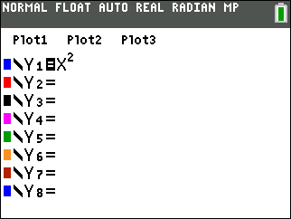
7. After storing the equation, now set up the table to see the x- and y-values. Press ` ç and set up the table as shown at the right. Once the table is set, press ` ê. | 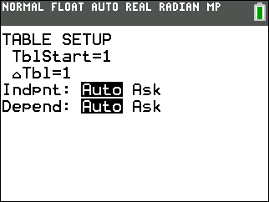
8. How many student desks would be needed to create an 8 × 8 table?
9. If there are 121 desks and you wanted only one table, what is the largest size table that can be created?

10. Would this be an efficient way to seat everyone?
Why or why not?

11. Write about what a square number is and why it is called a “square number”.

12. Give at least 3 examples of square numbers.

