Introduction
How do we measure temperatures? In almost all countries of the world, the Celsius scale (formerly called the centigrade scale) is used in everyday life, science, and industry. This scale sets the freezing temperature of water at 0 and the boiling temperature at 100. The distance between these two points is divided into 100 equal intervals called degrees.
The United States uses the Fahrenheit scale. This scale employs a smaller degree unit than the Celsius scale and its freezing point is set to a different temperature. For the temperatures we commonly use and observe, Celsius readings are lower than Fahrenheit readings. You have probably noticed this if you have seen a thermometer that has both Celsius and Fahrenheit markings or if you have driven by signs at banks and other businesses that display time and dual temperatures.
In this experiment, you will collect data in both Celsius and Fahrenheit temperatures using two temperature probes in the same cups of water. Based on the data collected, you will develop an equation to convert Celsius temperatures to Fahrenheit temperatures.
Objectives
In this activity you will:
- Graph scatter plots
  - Analyze and graph linear equations
  - Compute and model slope
- Derive and apply a conversion equation
You'll Need

- 2 TI-84 Plus CE calculators, with Vernier EasyData™ App
- 2 Vernier Easy Temps® Sensors
- 5 cups per student group, of water with varying temperatures
Using the Vernier EasyTemp® and Vernier EasyData® App  Connect the handheld with the EasyTemp sensor, and EasyData will immediately open, and the temperature probe will begin collecting temperature data. In the EasyData app, the tabs at the bottom indicate the menus that can be accessed by pressing the actual calculator keys directly below the tab. | 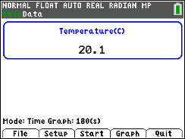  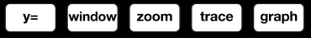

Collecting the Data
- Each group will need 5 cups with water of varying temperatures.
- One cup of water should be room temperature or fresh out of the tap.
- One should be very cold with many solid ice cubes in the cup.
- One should have water that is cool with only a few cubes of ice that have just melted.
- One should be considerably warmer than room temperature.
- One should be either boiling water or very close to boiling.
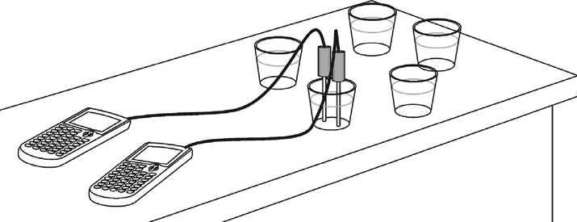  - Link two EasyTemp probes to two different TI-84 Plus CE calculators. Refer to the figure below.  - When you connect the EasyTemp probe to your TI-84 Plus CE calculator, the EasyData App will launch automatically.  - The EasyData information screen is displayed for about 3 seconds followed by the main screen. The EasyData App identifies the temperature sensor. The main screen of EasyData will display the current temperature across the top of the screen in degrees Celsius.  - Press the o key to access the File menu and select 1:New by pressing À . Or, since 1:New is highlighted, you can press Í. This resets the program and clears out old data. | 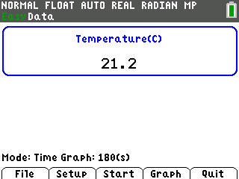  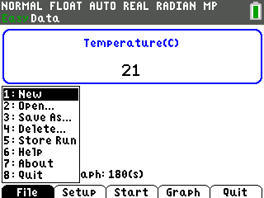
- Leave one of the calculators with the Celsius setting but the other calculator will need to be changed to Fahrenheit. Press the p key to select Setup and choose 1:Temp from the menu displayed. | 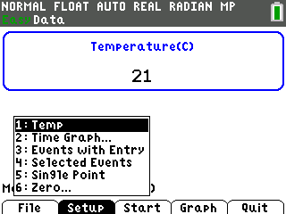
- From the next screen, press the p key to select Units. Select 2:(F) from the menu to change from Celsius to Fahrenheit.  - When the screen appears confirming that your choice has been accepted, select OK by pressing s. | 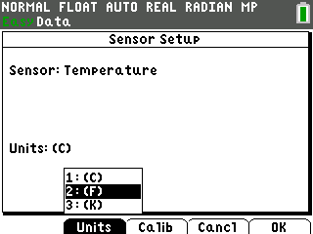
- You will be returned to the main screen of the App. Select Setup on both calculators and select 4:Selected Events.  - You will be returned to the main screen of the App. Select Setup on both calculators and select 4:Selected Events.  - You will be taken to a screen that displays the temperature reading in real time at the top of the screen.  - To begin collecting data, position the two probes next to each other but not touching. Select Start by pressing q. Let the first reading be the room temperature. To record the temperature of the first reading, select Keep.  - Repeat the procedure until you have collected the six readings. This includes the air temperature and the five cups of water. It does not matter which order the readings are taken in.  Record the readings in the table in the Looking at the Results section at the very end. The important thing is to keep the two probes close together so they are measuring the same temperature. Select Keep at the same time on both calculators after the temperature readings have become relatively stable. | 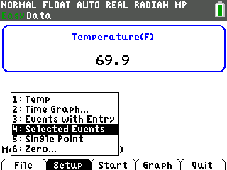  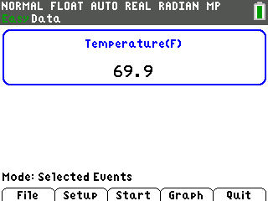  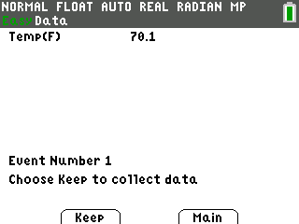
- With each recorded value, a new data point will be displayed on the graph. When finished, select Stop by pressing q. The graph of all the data points will be displayed. At this point you can use the right and left arrow keys to view the coordinates of the points. | 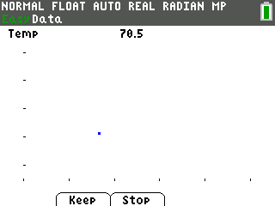
- You will NOT analyze the data from within the App. Select Main by pressing s and then Quit to exit the App. | 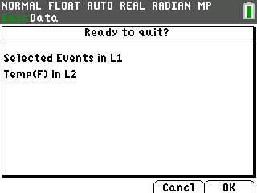
- The new screen will inform you that your data are in lists one and two. L1 contains the numbers 1-6. The temperatures are stored in L2. The Celsius and Fahrenheit readings are stored in L2 on two separate calculators. The lists need to be in both calculators so that the Celsius data is in L1 and the Fahrenheit data is in L2. This allows you to examine the relationship between them.  - On the calculator that took the readings in the Celsius scale, press … and select 1:Edit to see the lists displayed. We need to replace L1 with the values in L2.  - Position the cursor so the name L1 is highlighted. Press y 9 to access L2. You will see L2 at the bottom of the screen. Press Í.  - L1 should fill in with the data from L2.  - Link the two calculators together and pass L1 from the Celsius calculator to the Fahrenheit calculator and the L2 from the Fahrenheit calculator to the Celsius calculator. In both cases, because the receiving calculator already has data in the target list, your calculator will ask you if you would like to 2:Overwrite the data.  - When the list is sent successfully, you will receive confirmation. | 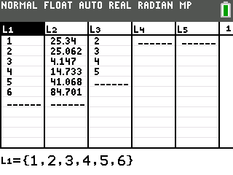  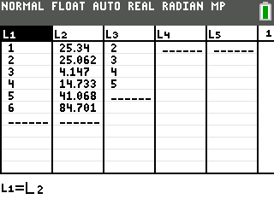  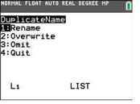
- Press … and select 1:Edit to see the lists displayed on both calculators. Link both L1 and L2 to all students in the class. | 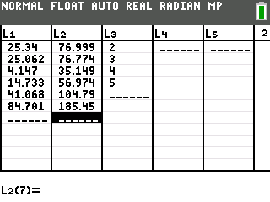
Data Analysis
- Set up a scatter plot with temperature in degrees Celsius as the independent variable (Xlist) and the corresponding temperature in degrees Fahrenheit as the dependent variable (Ylist). | 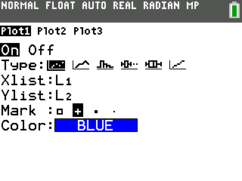
- Press q and select 9:ZoomStat to see the graph of the scatter plot. When r is selected, you may have trouble scrolling through the points. When a scatter plot is traced using the right arrow key, the points are scrolled through in the order they were entered in the data list of the independent variable. Often this is the order in which they appear on the screen from left to right, but that is not what happened in this scatter plot. The right arrow will allow you to scroll through the points in the order they are listed in L1 and L2 regardless of where they appear on the screen. | 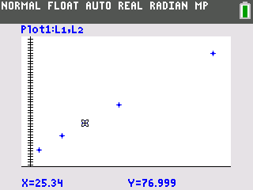
- Sort the lists so that the data points are in order from smallest to largest. Use the calculator to sort the list for you. Press … and select 2:SortA( from the menu. This will sort the list in ascending order.
- This takes you to the home screen. If you enter L1, the calculator will arrange the numbers in list one in order, but it will leave the numbers in L2 alone. Because the numbers in L2 are related to the numbers in L1, the entire row needs to be carried along with the lead entry from L1. To do this, type SortA(L1, L2). Press Í to execute the command. | 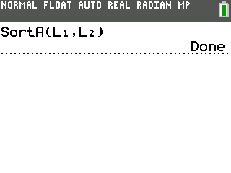
- Press … and select 1:Edit.Your data has been sorted. Notice that the elements in L1 have been listed in ascending order, as have their corresponding values in L2. | 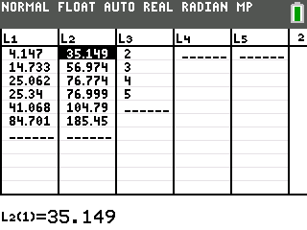
- Now the points can be traced in order from left to right. | 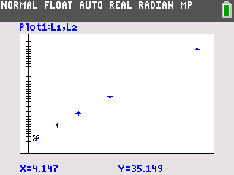
- Next, find the trend line or the line of best fit. There are several ways to do this, and your teacher may advise you to use a specific method from the list below:
- One method is to estimate the slope and Y-intercept and enter it in Y1. Next, check to see how closely it matches the points and adjust the values until you are satisfied with the fit. This can be done manually or using the Manual-Fit option under the … ~ CALC menu.
- Another method is to choose two ordered pairs on the graph and calculate the slope. Then, using the slope and Y-intercept (or any other point), find the equation of the line, graph the line, and see how well it fits the data points.
- Using the built-in linear regression feature of the calculator is a quick and accurate method.
- The calculator can help with the computation of the slope. After tracing to the first point, press y z to 5 and return to the home screen. Press „ ¿ ƒ A Í. This will store the X-value from the point you last traced on the graph screen to the variable A. Repeat this procedure to store the Y-value in B. Press ƒ Y¿ ƒ B Í. | 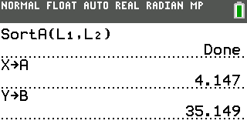
- Press s and then r and use the right arrow key to move to the last point on the right. Once again, notice the X- and Y-values displayed at the bottom of the screen.

- Repeat the procedure to store these values in C and D. Press y z to access 5 and return to the home screen. Press „ ¿ ƒ C Í. This will store the X-value from the last point to the variable C. Next, press ƒ Y ¿ ƒ D Í. | 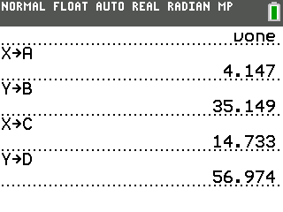
- Using the slope definition, have the calculator find the slope and store the value in M as shown. Be sure to enclose both the numerator and denominator in parentheses. The keystroke sequence is £ ƒ D j ƒ B ¤ ¥ £ ƒ C j ƒ A ¤ ¿ ƒ M Í. | 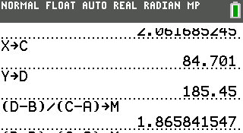
- Go to the o window and press ƒ M „ to type in MX behind Y1. To change the color of the line press || to highlight the slash and color icon and press Í. Press ~ or | to scroll through the colors. | 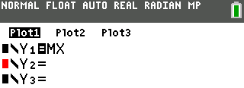  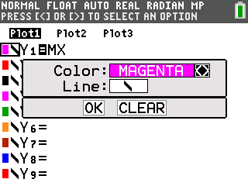
- Press s to see how closely this line fits the points. In the example shown, it looks like the slope is correct since the line is parallel to an imaginary line through the points. The vertical position of the line needs to be moved up by adjusting the Y-intercept. | 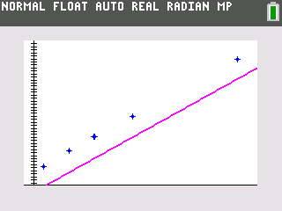
- Determine how much your line is below where it needs to be. Add this value to the equation you entered in Y1. Think about the relationship between Celsius and Fahrenheit. What is 0 degrees Celsius in Fahrenheit?  - Press s to see how closely this fits the points. | 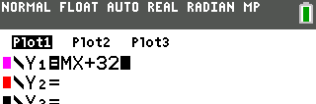  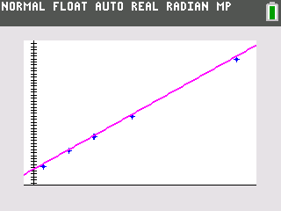
- Look up the formula to convert Celsius to Fahrenheit and enter it in Y2. Press | | to highlight the slash and color icon and press Í in front of Y2. Press Í to change the color of the line and the symbol. Choose the symbol with the ball and the small line to the left of the ball. Then press † and Í on OK. | 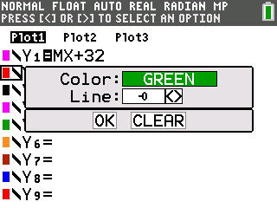
- Press s. Y1 is graphed normally. A circular cursor traces the leading edge of the graph of Y2 and helps emphasize how close the lines are to each other. | 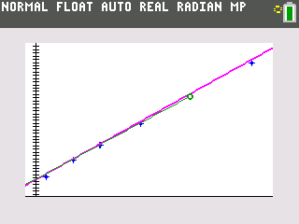
- Press y 0. This will allow you to see how close your regression equation is to the formula. A numerical comparison rather than just the visual comparison on the graph screen can confirm that the two lines are very close to being the same line. | 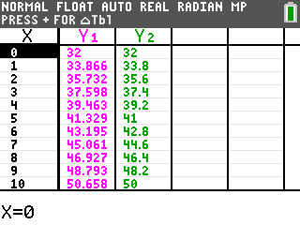
- Press y - to access the TABLE SETUP Menu. The defaults on the table are to start at zero, to count by one, and to automatically fill in all the values. With these settings, it could take a while to scroll and find specific values.  - To take more control over what numbers the table displays, change the Indpnt: to Ask instead of Auto. Leave the Depend: set on Auto. Use the arrow keys to position the cursor on the word Ask and then press Í. | 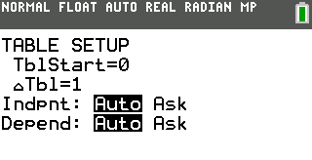  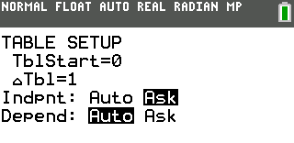
- Press y s to access the TABLE. You will be taken to a blank table. Type zero. It will be entered beside the X= at the bottom of the screen. Pressing Í will fill in both Y1 and Y2. Remember: you entered the Y-intercept from your knowledge of the fact that 0 degrees Celsius is 32 degrees Fahrenheit. So, this exact match is not an indicator for all points. | 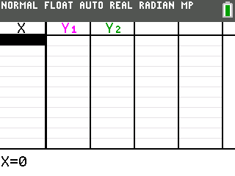  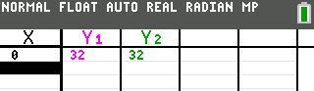
- Another common set of values is the boiling point of water. Celsius is 100 degrees and Fahrenheit is 212. Type in 100 beside the X= and compare the value in Y1 to the value in Y2. | 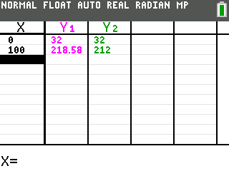
Looking at the Results
- Fill in the table with the data you collected from the six readings.
Cup of Water | °C | °F
Air room temperature
Tap water
Ice water (lots of ice still present)
Cool water, ice has melted
Warm water
Very hot/ boiling water

- Why is the order in which you collect the data not important?

- You put the Celsius readings in L1 and the Fahrenheit readings in L2. Why did you throw away the numbers 1-6 that were originally in L1 after running the EasyData App?

- You used two of these data points to find the slope of the regression equation. Would you get the same answer as if you used two different points? Explain.

- What was your regression equation?
- The definition of the slope of a line is the change in Y divided by the change in X. For this problem, that would be the change in Fahrenheit divided by the change in Celsius. Use your own words to state what that means in respect to this problem.

- What was the regression equation the calculator found?
- What is a reasonable explanation for why the two regression equations are different from each other and also different from the formula?
- If your equation is in Y1, the formula is in Y2, and the calculator's regression equation is in Y3, use the Ask feature on the table of the calculator and fill in this chart for the given temperatures.
X°C | Y1 | Y2 | Y3
5
15
25
35
60
85

