Part 1 – Ordering Squares
Use the Home screen to put the following numbers in order from least to greatest.

1. 4 10 2 6

2. –1 5 –3 7

Part 2 – Finding the Running Distance
You have been assigned to work with the track coach to find a new route for the cross-country team and have found the following options. The coach wants the team to have 3 different routes, short, medium, and long. The short route must be between 1 and 2.5 kilometers; the medium route must be between 3 and 4 kilometers; and the long route must be between 4 and 6 kilometers.
Find the distance around each square. Classify as short, medium, long, or none.
3.  2 square km  Answer: | 4.  3 square km  Answer:
5.  1.2 square km  Answer: | 6.  0.3 square km  Answer:
7. Explain how you determined which perimeter fit in which category.

Part 3 – Mixed Up Carpets
Jayden and Jamal are doing charity work helping build houses. They have been assigned to put the carpet rolls in the correct rooms. However, when the carpet was received, the room labels were missing. They know the square footage of each roll and need to determine where it belongs.
Jamal gets the floor plans and sees that the rooms have the length of each wall but not the square footage. Help them find the correct room for each roll.
Bedroom 1 – 10 ft walls Bedroom 2 – 13 ft walls Study – 22 ft walls
Hallway – 3 ft × 14 ft Living Room – 14 ft × 18 ft.
8.  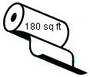  Answer: |  | 9.  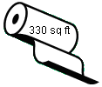  Answer:
10.  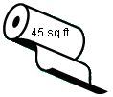  Answer: |  | 11.  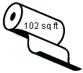  Answer:
Part 4 – Estimating Square Roots
Estimate each of the following. Then find each to 2 decimal places using a calculator. Press ` ¢, enter the number, and then e. |  |  | 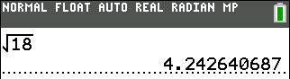
12. | 13. |  |  | 14.
15. | 16. |  |  | 17.

