Part 1 – Marginal Distributions
At times, an individual can be categorized by two categorical variables. The data is displayed in a two-way table, where the independent variable is in the columns and the dependent variable is in the rows.
The data table below is an example of a two-way table. It is from a survey of New Yorkers from September 2008.
 |  | Party Affiliation
 |  | Republican | Democrat | Independent
Candidate | Obama | 58 | 691 | 20
Candidate | McCain | 444 | 63 | 16
Candidate | Other | 5 | 8 | 1
Candidate | Not Sure | 21 | 23 | 3

This data will be manipulated using the Cell Sheet Application. To start the application, press ❶ and select CelSheet.  To open the data file (called TWOWAY), select MENU by pressing . Now choose File, then OPEN, and use the arrows to choose TWOWAY. | 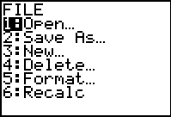
When one variable is “ignored” and the proportion of the other variable that fits in each category is calculated, marginal distributions are found. There are two sets of marginal distributions for each two-way table.

Calculate the Marginal Distributions for the Party Affiliation Variable.
Step 1: Find the sum of each column. The sum of Column B is found by going to cell B7 and typing = sum(B2:B5).  Notes:  - Use the  key for an equals sign.  - The sum() command is obtained by pressing   and select the command.  - B2:B5 are the start:stop locations of the summing. | 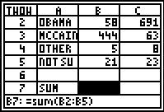
To sum the next two cells, just copy and paste the formula. Press □  to copy the formula, move to cell C6 and press  to paste, then move to cell C7 and press .  To end the pasting, just press ❻.  Record these results in the table that appeared at the beginning of this activity sheet. | 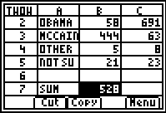
Step 2: Calculate the total number of respondents. To do this, you will find the sum of the three numbers you just summed. Go to cell E7and type the correct formula.  Record this result in the table that appeared at the beginning of this activity sheet. | 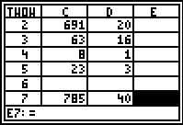
Step 3: Calculate the proportions of respondents for each affiliation. To do this, enter formulas in row 8 under each Column B-D.  For the Republications, the proportion formula is =B7/E7. | 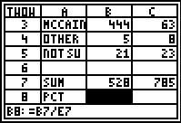
- What percent of the respondents are:
Republican: ___________Democrat: ____________Independent: __________

Calculate the Marginal Distributions for the Candidates.
Calculate the sums for each candidate as was done earlier with the party affiliations using column E for the sums and Column F for the percentages.
Write your answers in percents.
Obama: _____________ McCain: ______________
Other: _______________ Not Sure: _____________

- What can you infer from the marginal distribution for candidate choice?

Part 2 – Conditional Distributions
To study possible relationships between two categorical variables, one examines conditional distributions, the distributions of one variable for given categories of the other variable.
Restrict your attention to the Republicans. That is, only consider the respondents that declare themselves Republicans.
The conditional distribution for Obama, is .
Quit the cell sheet application by pressing  and selecting Quit.
- On the Home screen, using your calculated totals and the table at the start of this activity, calculate the percentages of Republicans who favored:
Obama: _____________ McCain: ______________
Other: _______________ Not Sure: _____________
Record the percentages in the chart below. Check your work by verifying that the column totals 100%.
Restrict your attention to the Democrats, then to the Independents, and fill in each space in the chart.
 | Republican | Democrat | Independent
Obama
McCain
Other
Not Sure
- Pick a box from the table and explain what the percentage represents.

Restrict your attention to each candidate choice now. Calculate the conditional distributions and fill in the chart below.
 | Republican | Democrat | Independent
Obama
McCain
Other
Not Sure

- Pick a box from the table and explain what the percentage represents.

Homework
The following table of data came from the responses to the question “In general, do you favor or oppose the building of more nuclear power plants in the United States?”
 | Echo Boomers  (18–31) | Gen X  (32–43) | Baby Boomers  (42–62) | Matures  (63+)
Strongly favor | 48 | 62 | 55 | 57
Moderately favor | 60 | 94 | 61 | 47
Moderately oppose | 64 | 57 | 33 | 24
Strongly oppose | 51 | 59 | 35 | 16
Unsure | 81 | 63 | 35 | 19

Open the spreadsheet NUCLEAR. Calculate the marginal distributions for age and opinion. Then, calculate the conditional distributions given age and opinion. Create a chart similar to the one in Problems 1 and 2.

