Run the program DATASET.
Problem 1 – Voter Data
The lists DEM80 and DEM84 show the percent of the popular vote that was won by the Democratic presidential candidates in the 1980 and 1984 elections. Both candidates, Jimmy Carter in 1980 and Walter Mondale in 1984, were defeated by the Republican Ronald Reagan.  Step 1: On the Home screen, press  and select SetUpEditor. Then select DEM80 and DEM84 from  . Press . | 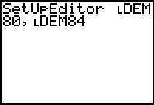
Step 2: Now, you will create a scatter plot of the data. Press   and select Plot1. Change the settings to those shown at the right.  Use   to enter the list names.  Step 3: Press  and select ZoomStat to see the graph. | 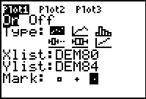
Step 4: Inspect the graph to determine if the data set represents a function. In order to be a function, recall that a single input can have only one output value. In other words, each x-value is matched with only one y-value.
Any set of ordered pairs is called a relation. A relation may or may not be a function.
- Which term do you think best represents the graphed presidential election data? Explain why you chose the term you did.
◻ function ◻ relation

- A simple test involving a line being placed anywhere on a graph may be used to determine if a graph represents a function. When a ______ line is placed on a graph and the graph intersects the line more than once, the graph is not a function.
◻ horizontal ◻ vertical
Step 5: Use the type of line you selected in the previous question to test whether the graph is a function. From the Graph screen, press   and select either Horizontal or Vertical.  Use the arrow keys to move the line across the screen. | 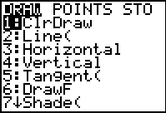

With large data sets such as this one, the line alone can be a difficult test. It is also helpful to sort the data to see if each x-value is paired with just one y-value.
Step 6: Sort DEM80 in ascending order. From the Home screen, press  and select SortA(. Enter DEM80, DEM84). Press .  Press   to see the sorted lists. | 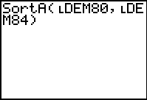
- After sorting the data, it is easier to see that some of the x-values repeat in the table. What does this mean?

Problem 2 – Average Heights
The lists AGE and HGHT give the mean heights in cm of a group of children in Kalama, an Egyptian village that is the site of a study of nutrition in developing countries. The data were obtained by measuring the heights of all 161 children in the village each month over several years. Ages are in months.
On the Home screen, press  and select SetUpEditor. Then select AGE and HGHT from  . Press .  Follow the steps from Problem 1 to determine if this data set is a function or a relation. | 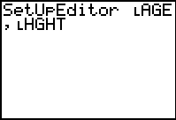
- The data set represents a function. Explain your reasoning.
◻ agree ◻ disagree

- This was determined by...
◻ vertical line test ◻ viewing spreadsheet data
◻ other (Please describe your method if you choose other.)_____________________
______________________________________________________________________

Problem 3 – Retained Impressions
The lists SPENT and MILIM give data that appeared in the Wall Street Journal. The retained impressions were based on a survey of 4,000 adults, in which regular product users were asked to cite a commercial they had seen for that product category in the past week. The data include 1983 spending in millions and MILIMP (millions of retained impressions per week).

Use the SetUpEditor for lists SPENT and MILIM. Follow the steps from Problem 1 to determine if this data set is a function or a relation.
- The data set represents a function. Explain your reasoning.
◻ agree ◻ disagree

- This was determined by...
◻ vertical line test ◻ viewing spreadsheet data
◻ other (Please describe your method if you choose other.)_____________________
______________________________________________________________________

