Part 1 – Multiplying Fractions with Area Models
For each exercise, draw an area model representation of the multiplication. Report all fractions in lowest terms.
1. Multiply.  Press the green a key, then ! for ∏. Choose the fraction template by pressing e. Type the numerator 4. Press ► 5 to type the denominator 5. Press ► to move out of the denominator and multiply. Press *. Press a ∏ e 3 to type the numerator of the second fraction, 3. Press ► 5 to type the denominator 5. Press e.  Write the fraction. ____________  What percent of the 1 by 1 square is shaded? ______ | 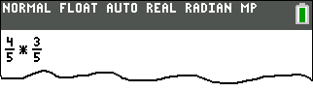  1  1
2. Multiply.  Press a ∏ e 2 to type the numerator 2. Press ► 3 to type the denominator 3. Press ► to move out of the denominator and multiply. Press *. Press a ∏ e 1 to type the numerator of the second fraction, 1. Press ► 4 to type the denominator 4. Press e.  Write the fraction. ____________  What percent of the 1 by 1 square is shaded? ______  (Round your answer to the nearest tenth of a percent.) | 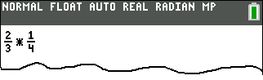  1  1
3. Multiply.  To get the mixed fraction math template, press a ∏ and choose the second option. Press 1 ► 1 ► 2. Press ► to move out of the denominator and press *. To enter the second fraction press a ∏ e 3 ► 4. Press e.  Write the fraction. ____________ | 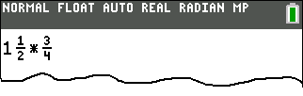  1  1  1
What percent of the 1 by 1 square is shaded? ______

Part 2 – Dividing Fractions with Fraction Tiles
Show each division exercise with fraction tiles.
4. Divide 2 ÷ .  Press 2 / a ∏ e 1 ► 3. Press e.  Write the answer. ____________ | 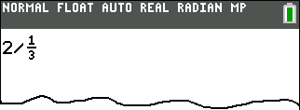
5. Kara has cup of almond milk left. She uses cup each morning with breakfast. How many breakfast servings does Kara have left?  Press a ∏ e 1 ► 2. Press ► to move out of the denominator and select /. Enter the second fraction, a ∏ e 1 ► 4.  Press e.  Write the answer. ____________ | 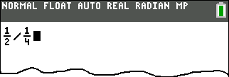
6. Write a story problem in which the number 4 is divided by the fraction . Use the context of the problem to explain the relationship between multiplication and division. | 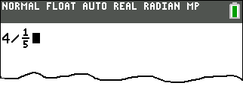

Part 3 – Multiplying and Dividing Decimals
For Exercises 7, 8, 9, and 10, estimate the answer before calculating the value.
7. 26.45 × 0.25  First, my estimate is _________.  Now type 2 6 . 4 5 and multiply this by 0.25 by pressing * 0 . 2 5 e.  26.45 × 0.25 = ___________ | 8. 35.5 ÷ 4.2  First, my estimate is _________.  Now type 3 5 . 5 and select /.  Enter the second decimal, 4 . 2.  Press e.  35.5 ÷ 4.2 ≈ _________  (Round to the nearest thousandth.)
9. 14.25 × 1.0825  First, my estimate is ________.  Use keystrokes similar to those shown in Exercises 7 and 8 to find  14.25 × 1.0825 ≈ ___________.  (Round to the nearest thousandth.) | 10. 325 ÷ 18.25  First, my estimate is ________.  Use keystrokes similar to those shown in Exercises 7 and 8 to find  325 ÷ 18.25 ≈ __________.  (Round to the nearest thousandth.)
For Exercises 11 and 12, circle the correct choice.
Explain how you could determine the correct value without a calculator by using estimation.
11. Which of these is 9.85 x 2.4?  A. 2364  B. 236.4  C. 23.64  D. 2.364 | 12. Which of these is 5006.11 ÷ 52.42?  A. 955  B. 95.5  C. 9.55  D. 0.955
13. When Jeffrey was born, his parents planted a tree in the backyard. He has decided on his 13th birthday to see how tall the tree is. Use proportions to determine the tree height. Show your work.  The tip of Jeffrey’s shadow and the tip of tree’s shadow  coincide here. |  | 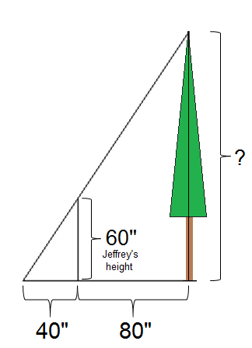  64”  24”  15’  ?
  Part 4 – Solve Similarity Problems
  Use the diagrams to help you solve the problem.
14. Moriah is 64 inches tall and casts a shadow that is 24 inches long. She is standing next to a billboard that casts a shadow 15 feet long. Use proportions to determine the distance from the ground to the top of the billboard. Show your work. |  | 