Introduction
One problem that has always confronted society is the spread of disease. Viruses cause some of the deadliest diseases we know of. When you think of diseases that are easily spread from person to person, you probably think of the common cold, influenza, and chicken pox, along with one of the most dreaded diseases of our time: AIDS. Viruses cause all of these diseases, and the members of a population can very quickly share them.

Objectives
In this activity, you will:
- simulate the spread of a virus.
- produce a graph of the virus data.
- analyze the data.
You’ll need
- TI-84 Plus CE
Collecting the Data
Prior to the activity, your teacher will assign each student in the class should be a consecutive integer starting with the number 1. This number will identify the individuals who will become infected with the virus that will be introduced to this healthy population.
Using the TI-84 Plus CE, your teacher will then start the game by generating the random numbers to represent those who are infected by the virus using the directions that follow.
As the random numbers are generated, if your number is chosen, you will sit down. This represents those who are infected by the virus. You will record the data on the printed Data Table. Following the activity, you will then enter the data from the Data Table for the entire class, into your calculators for further analysis below.

Data Analysis
- Now you will enter your data from the data table into the calculator. Press … Í to return to the List Editor. Clear all lists of data. Enter the number for each trial in L1 and the class data, those infected, in L2. The screen at the right represents sample data for this simulation. Your results in L2 may be different. | 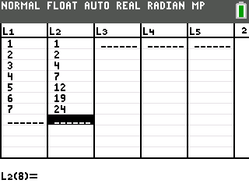
- Press y ,. Press Í to select 1:Plot1. Set your TI-84 Plus CE as shown at the right. | 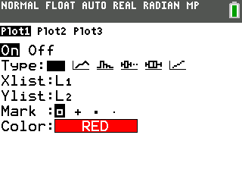
- Press p and set your window to reflect the number of trials. In the screen at the right, there were 10 trials, so 10 was entered for Xmax. If your simulation took more than 10 trials, enter that number for Xmax. The Ymax value is the maximum number of students in the class. In this case the setting is bigger so we will be able to see the graph of all data points. | 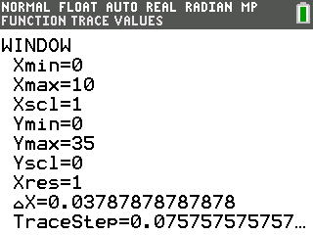
- Press s. You have a graphical representation of the spread of the virus in your classroom. This common type of graph is called a scatter plot. You told the TI-84 Plus CE to produce one of these when you set up STAT PLOT for your data. (See step 2.) | 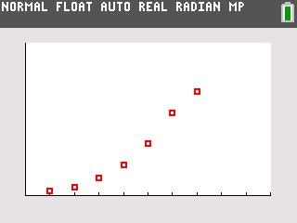

Data Collection
Data Table
Trial Number | Individuals Infected | Change in Individuals Infected
1
2
3
4
5
6
7
8
9
10
11
12
13
14
15
16
17
18
19
20

Looking at the Results
1. Looking at your graph, how would you describe the spread of the virus from start to end?

2. Using the ~ key, move along your scatter plot and estimate when the virus is spreading fastest. Between what two consecutive trials did this happen?

3. Looking at your data table, you can see that there is a constant change of 1 in the first column. Is there a constant change in the number of infected in the second column? Complete the data table to determine the rate of change of those infected between consecutive trials. What is the label that needs to be applied to these values?

4. The ratio of Change in Number Infected to Change in Trial Number gives a numerical representation of the rate of the spread of the virus. Does the greatest rate of change in the data table match the value you found in the previous question? Explain why or why not. What does this mean about the spread of the virus?

5. Why does your graph level off toward the end?

6. Use the information you learned in this activity to describe the spread of the virus causing the common cold.
Going Further
In colder climates, what are some possible reasons that more people seem to become infected with the cold or flu virus in the winter more often? ·

In general, why are diseases that are caused by bacteria more easily treated than viral diseases?

