Activity Overview  In this activity, students will use a simulation to find the experimental probability of independent events. They will find the sample space and then compare the experimental and theoretical probabilities. Then students are introduced to dependent events and the formula for conditional probability.  Topic: Probability  - Simulations  - Independent and dependent events  - Conditional probability  - Law of large numbers  - Experimental and theoretical probabilities  Teacher Preparation and Notes  - This activity is intended to be an introduction to finding the theoretical probability for independent events. Specific directions and inquiry questions are part of the student worksheet so this can be an independent or group activity. It does not need to be teacher led.  - Students will need groups to compile data.  - If time is limited, Problem 1 can be done in class the first day and Problem 2 and 3 can be done in class the second day.  - Have students clear lists by pressing  ☹ and select ClrAllLists prior to beginning the activity.  - To download the student worksheet, go to education.ti.com/exchange and enter “11693” in the keyword search box.  Suggested Related Activities  To download any activity listed, go to education.ti.com/exchange and enter the number in the keyword search box.  - Compound Events (TI-NspireTM technology) — 10136  - Binomial Experiments (TI-NspireTM technology) — 9999  - Gambler’s Fallacy: Lucky Streaks and Slumps (TI-84 Plus family) — 4241 | 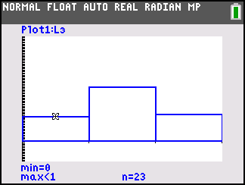  This activity utilizes MathPrintTM functionality and includes screen captures taken from the TI-84 Plus C Silver Edition. It is also appropriate for use with the TI-83 Plus, TI-84 Plus, and TI-84 Plus Silver Edition, but slight variances may be found within the directions.  Compatible Devices:  - TI-84 Plus Family  - TI-84 Plus C Silver Edition  Associated Materials:  - IndependenceIsTheWord_Student.pdf  - IndependenceIsTheWord _Student.doc  Click HERE for Graphing Calculator Tutorials.

Problem 1 – Simulating Independent Events
As an introduction, explain to students the definition of independent events and give the following examples listed.
Definition:
Two events A and B are independent if knowing the outcome of one does not change the probability that the other occurs.
Examples:
Independent: Each time a coin is tossed it is an independent event since the outcome of the first toss does not influence the result of the second toss.
Not Independent: Picking cards from a standard deck of cards is not independent since knowing the outcome of the first draw does change the probability for the second draw.
Review with students how to use the Random Integer generator to simulate the tossing of a coin. The command randInt(0,1) will generate one toss, where 0 represents heads and 1 represents tails. The command randInt (0,1,50) will generate 50 tosses.
To start the activity, students are to predict the probabilities of all the possible outcomes of tossing a coin twice.  In the simulation, students will let 0 represent heads and 1 represent tails. In list L1 students should arrow up to highlight L1 and enter the command randInt(0,1,100). They can access the randInt command by pressing , arrow over to the PRB menu and choosing randInt(.  Students will need to enter the same command for list L2. Each row will represent one trial consisting of 2 tosses, for a total of 100 trials.  Students should use the arrow keys to highlight L3 and enter L1 + L2 to add lists L1 and L2, calculating the number of tails for each trial. The possible numbers are 0, 1, and 2.  Note: Students can enter L1 by pressing  , and enter L2 by pressing  .  Note: Students can generate additional sets of data by re-entering the command randInt(0,1,100) in the formula bars of L1 and L2. They will also need to re-enter the formula  L1 + L2 in L3. | 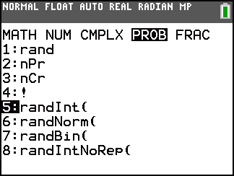  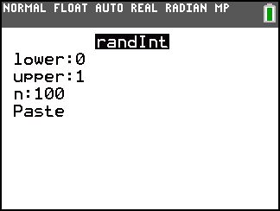  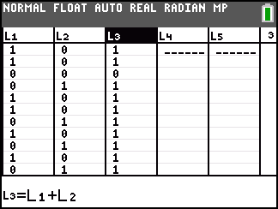
Student can use a histogram to determine number of times each outcome occurred. They are to make a histogram of the values in L3 by opening the Statplot menu ( ) and choosing Plot1, and adjusting the settings as shown in the screen shot.  Students need to make sure that all other plots are turned off. They can press  and match the settings shown in the screenshot at the right to view the plot in an appropriate window. | 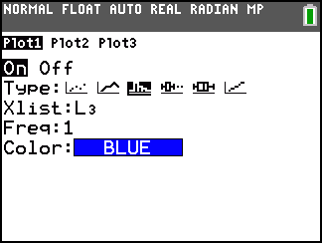  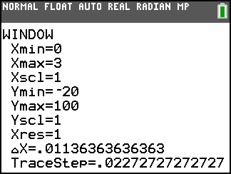
To find the total number of times 0, 1, and 2 tails occurred, students should press . This shows the height (n) of each bar of the histogram at the bottom of the screen. Students may use the left and right arrow keys to move between the bars.

Students are to then calculate the experimental probabilities of tossing 0, 1, and 2 tails. Since the total number of trials is 100, the probability will be n with the decimal moved to the left two places. They will need to recreate the histogram each time the data is recalculated.

Help students combine their results as a group, where the total number of trials will be 100 multiplied by the number of students in the group, and as a class, where the total number of trials will be 100 multiplied by the number of students.

Students are to then to compute the theoretical probabilities of tossing 0, 1, and 2 tails using the sample space. This is a good place to review the Law of Large numbers, where the experimental probability approaches the theoretical probability as the number of trials increase.

After answering the questions on page 2 of the worksheet, students should determine that if two events A and B are independent, then P(A and B) = P(A)P(B).

Problem 2 – One Independent and One Dependent
Students will now consider probabilities where the events are not independent. A basket contains 3 green balls, 3 white balls, and 1 red ball. Students should understand that the first pick from the basket is an independent event, but the second event depends on what color the first ball drawn was because it was not replaced.  Explain to students that the probability of choosing a white ball after a red ball was already drawn is an example of conditional probability. | 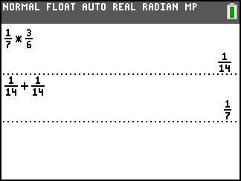
Problem 3 – Conditional Probability
Students are then given a table that contains the college enrollment (in thousands) for 2003.  The students may enter the values in the male and female columns in L1 and L2. They can use the arrows to navigate through the lists and enter the values. They may also highlight the formula bar of L3 and enter the formula: L1 + L2 to calculate the total of each age group. | 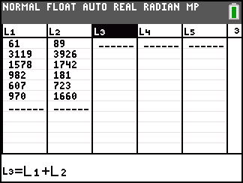
On the worksheet students are given the formula for conditional probability. The questions will direct them towards a better understand of how the formula is used to compute a probability. However, when the activity is finished a formal discussion on conditional probability is needed.

Note: When P(A) > 0, the conditional probability of B given A is .
- P(male) =
- P(15-17) =
- P(male and 15-17) =
- No because the events depend on how many others are female or of other ages.
- P(15-17|male) =

Homework – Solutions
1. a.  b. Example: Let 0 = girl, 1 = boy. Use three lists to simulate 3 children. Do simulation 100 times. Students should use the randInt(0,1,100) command to perform the simulation. This formula should be entered in the header of each of the three lists.  List 4 may be used to store the total values of boys and girls by entering: L1 + L2 + L3.  c. Answers will vary.  d. {GGG, GGB, GBG, GBB, BGG, BGB, BBG, BBB}  e.  f. | 2. a.  b.  c.  d.  e.
3. One child –  Both children –  Neither child – | 4. a.  b.  c.  d.  e.  f.  g.

