Introduction
What is the function of biological variation? What is the relationship between natural selection and reproduction? What is meant by survival of the fittest? In this activity, you will collect data on the members of your class and make note of the variation in your class.
If you and a friend were sitting in the African Savannah looking at a herd of zebras, you would probably have a tough time telling one zebra from another. To us, all zebras look pretty much alike, but every zebra is unique. In fact, in most populations of organisms, each individual is unique—different from any other individual in that population. This is called biological variation, and it is critical to the survival of a species. Populations of organisms depend on variations among their individuals. A population with little or no variation is at huge risk of being wiped out. Variation encourages natural selection, or survival of the fittest in a population. The fittest individuals in a population are more likely to survive, breed, and have offspring. Variation helps to ensure that at least some individuals in a population will be well-suited for survival in their environment.
Objectives
In this activity, you will:
- collect data from members of your class.
- produce a graph using the data.
- draw some conclusions based on the data and the graph
You’ll Need
- TI-84 Plus CE calculator
Collecting the Data
- Your teacher will describe the data that will be collected and how you will collect it.
- Press … Í. Enter all of your class data into L1. Press y 5 to go back to the Home Screen.
- Determine the average for all of the data. Press y 9. Press ~ ~ to go to Math, and then press 3:mean(. Press y d ¤ and then press Í.

- Record the Mean Value: ______________
- In mathematics, what is meant by the mean?
- Determine the median of the class data. Press y 9. Press ~ ~ to Math and then press 4:median(. Press y d ¤ and then press Í.

- Record the median value: _________________
- What is meant by the median of the data?
- Arrange the data in ascending order in L1. Press …, 2:SortA(. Press y d ¤ and then press Í. Press … Í to go back to the list screen.
- Record the smallest and largest entries from L1. Remember to include the appropriate units with all of your measurements.
Smallest: ___________________

Largest: ____________________

- Represent your data graphically by producing a Boxplot. Press y ,. Press Í to select 1:Plot1. Set your TI-84 Plus CE as shown at the right. |  | 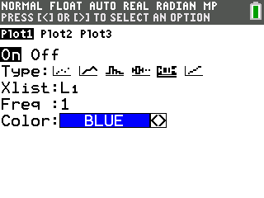
- Press p. Enter these settings:  - Xmin: slightly smaller than your smallest data value from #5 above  - Xmax: slightly larger than your largest data value  - Xscl: 0 Ymin: 0  - Ymax: 1 Yscl: 0 Xres: 1  Then, Press s.  - Sketch your graph on the grid to the right. |  | 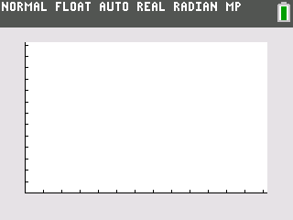
- Press r. The cursor will be at the median value for the data. Does this value match the value you recorded in #4 above? Press | and ~ to locate the five-number summary of your data.
- Record the five-number summary of your data here, and then describe what these values mean.

- MinX:

What does this mean?

- Q1:

What does this mean?

- Median:

What does this mean?

- Q3:

What does this mean?

- MaxX:

What does this mean?

Going Further: Questions for Discussion and Writing
- How was variation shown in your class?

- What is meant by survival of the fittest?

- Fitness does not always mean bigger, stronger, or faster. Think of some examples where being best fit may not mean being the biggest, strongest, or fastest.

- Describe the relationship between natural selection and reproduction.

- Describe the relationship between fitness and natural selection.
- In the wild, natural selection plays the key role in the maintenance of the gene pool in a population. When predators, such as lions, pursue a prey species, such as zebra, which zebras in the herd are most likely to fall prey to the lions? Explain.

- When humans hunt big game species such as deer, elk, caribou, or moose, which animals in the population do they seek? Compare this situation to your explanation in #6.

- Why is variation so important to a population?

- Describe some forms of variation that may be present, but not obvious, in a zebra herd. Sexual reproduction is probably the most important factor in maintaining variation in a population. Describe how sexual reproduction contributes to variation.

