Problem 1 – Setting Up the Problem
You decide to start your own business of washing dogs. First, you purchase $50 in supplies (buckets, towels, hoses, etc.). When you buy a 32 oz. bottle of shampoo for $4.79, the label says that it will wash a dog 32 times.
1. Find the per-dog cost for the shampoo. Describe how you found the amount.

2. Determine the cost equation for washing dogs. Don’t forget that you spent $50 on supplies.

3. Your mom offers to pay $3 for your dog to be washed. Explain below why you think your mom’s price is reasonable, too little, or too much. Remember, your goal is to make a profit.

Problem 2 – Finding the Break-Even Point
Graph the following equations: Y1=50+0.15X and Y2=3X
The graph can be used to answer Questions 4–7.
4. Find the intersection point of the two lines. (Press y / and select Intersect.) Record your answer below. | 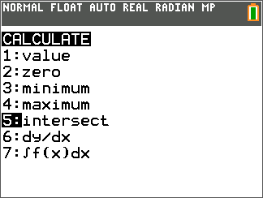
5. Interpret the point of intersection in terms of your business of washing dogs by explaining the meaning of the ordered pair (both x- and y-values).

6. Solve the problem algebraically by setting the equations equal to each other. (substitution)

7. Will you make a profit before you have to buy more shampoo? (Remember that you can wash 32 dogs with one bottle of shampoo.)

Problem 3 – Really Thinking About the Business Now
8. Change the equation Y2, which represents the amount you charge, and change it to a higher price of $4. Find the new intersection point. How does the ordered pair change as you increased the price?

9. What is the new system of equations? Solve the system using the $4 charge.

Using the table, you can calculate any number of dog washes and see how much it will cost you and how much money you will collect from customers. The table is set up for you to use the equations found in Y1 for cost and Y2 for money taken in.  Press y - and set Indpnt: Ask and Depend: Auto. Press y 0 to view the table. Enter the number of dog washes (X). | 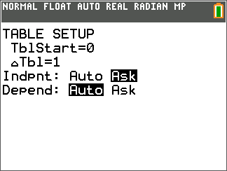
10. Calculate your profit by finding the difference in the two values. Show your work here:

13 dog washes 14 dog washes

15 dog washes 20 dog washes

Problem 4 – Calculating the Profit
11. Enter Y2–Y1 for Y3 and view the table to confirm your answers from Question 10. Then calculate some additional values for numbers of dog washes, and see how much profit (or loss) you would have as a result. | 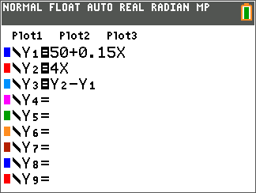
12. Graph your Profit (Y3). Describe the graph.

13. What does it mean to have points on the graph that lie below the horizontal axis (y = 0)?

What does the point on the graph on the horizontal axis represent?

Explain what you know about points that lie on the graph above the horizontal axis.

Extension/Homework
14. Explain what the result would be if you began to charge $3 for small dogs, $4 for medium, and $5 for larger dogs. How would this plan affect your profits?

15. What if you hired your younger sibling (or a neighbor or a friend) to help you with the bigger dogs and the laundry? How would you determine how much to pay him or her?

16. Describe how the price of the shampoo affects your equation and your profits. What if the shampoo price increases? What if it goes on sale?

17. Write an algebraic equation for the profit function used when you entered Y2–Y1 and the table filled itself with values of Y3 for you.

