Open the TI-Nspire document Position_and_Piecewise_  Velocity.tns.  You probably know that if an object is traveling at a constant rate, you can find its distance traveled during some time interval by using the formula distance = rate x time. But what happens if the object is traveling at a changing rate? In this activity, you will explore that question. | 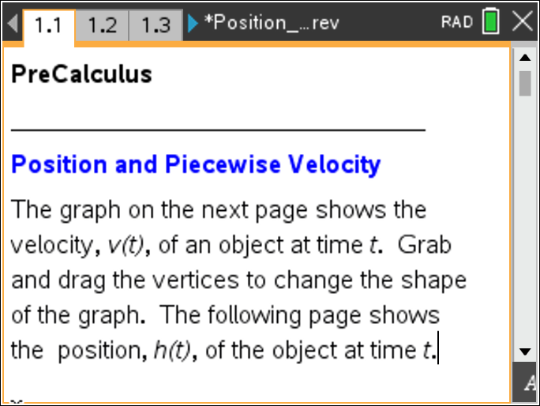

Move to page 1.2. | Press / ¢ and / ¡ to navigate through the lesson.
1. Drag the vertices on the graph so that your function goes through the following points: (0, 1), (1, 1), (2, 4), (3, -4), (4, 4) and (5, -4). This graph represents the velocity of an elevator ascending or descending floors in a building.
2. Grab the open point t, and drag it to the left and right.
a. The red point on the vertical bar represents the elevator. As you move point P, what do you notice about the elevator?

b. On which time intervals is the elevator moving up? What do you notice about the velocity on these time intervals?

c. On which time intervals is the elevator moving down? What do you notice about the velocity on these time intervals?

d. When is the velocity 0 floors/sec? What is happening to the elevator at those times?

3. a. When does the elevator seem to be moving the fastest? What do you notice about the velocity graph when the elevator is moving fastest?

b. When is the elevator moving the slowest? How do you know?

c. When is the elevator speeding up? When is it slowing down? How do you know?

Move to page 1.3.

4. This graph shows the height of the elevator vs. time. The height (or position) graph is increasing in some places and decreasing in others. Why?

Move to page 1.4.

5. The graph in the top work area shows the height of the elevator over time. The graph in the bottom work area shows the elevator’s velocity over time. What are the connections between the height of the elevator and the velocity?

Move back to page 1.2.

6. Drag the vertices to transform the graph so it models the velocity in the following scenario. Record a sketch of your graph, and explain how it reflects the scenario.

An elevator begins on the ground floor and starts rising. It speeds up consistently over the first second it rises, to eventually attain a speed of 4 floors /second. It then slows down, slowing consistently over the next second until it stops. It stays stopped for 1 second, and then descends at a faster and faster speed for 1 second. When it is descending at a speed of 4 floors /second, it begins to slow down until it comes to a stop 1 second later.

Sketch:

7. What floor is the elevator on when it stops at the end of the scenario? How did you determine this?

8. Is your graph the only graph that can be used to model the scenario in problem 5? Explain your thinking.

Move to page 1.3.

9. According to the position graph, what floor is the elevator on when it stops at the end of the scenario? How does this compare to your response in question 5?

Move back to page 1.2.

10. Drag the vertices to transform the graph so it models the following scenario. Record a sketch of your graph, and explain how it reflects the scenario.

An elevator begins on the ground floor. It rises, speeding up and then slowing down, until it comes to the 2nd floor 2 seconds later. It then descends, speeding up and then slowing down again until it reaches 2 floors below ground level 2 seconds later. It then rises, gaining speed as it goes. After 1 second, the elevator is on the ground floor.

Sketch:

Move to page 1.3.

11. Does the height graph on Page 1.3 reflect the scenario described in question 8? If not, what would you need to do to change the velocity graph so the height graph would look correct? Explain.

12. In general, how do the velocity and height graphs relate to each other? Explain your thinking.

This page intentionally left blank.

